#### **Option #1: Implementing SAS Hypothesis Testing**

**data TestScores;**

**input TScore_before TScore_after @@;**

**datalines;**

**123 133 135 136 129 135 117 137**

**120 142 138 135 140 121 145 147**

**136 168 140 152 146 129 137 145**

**;**

**run;**

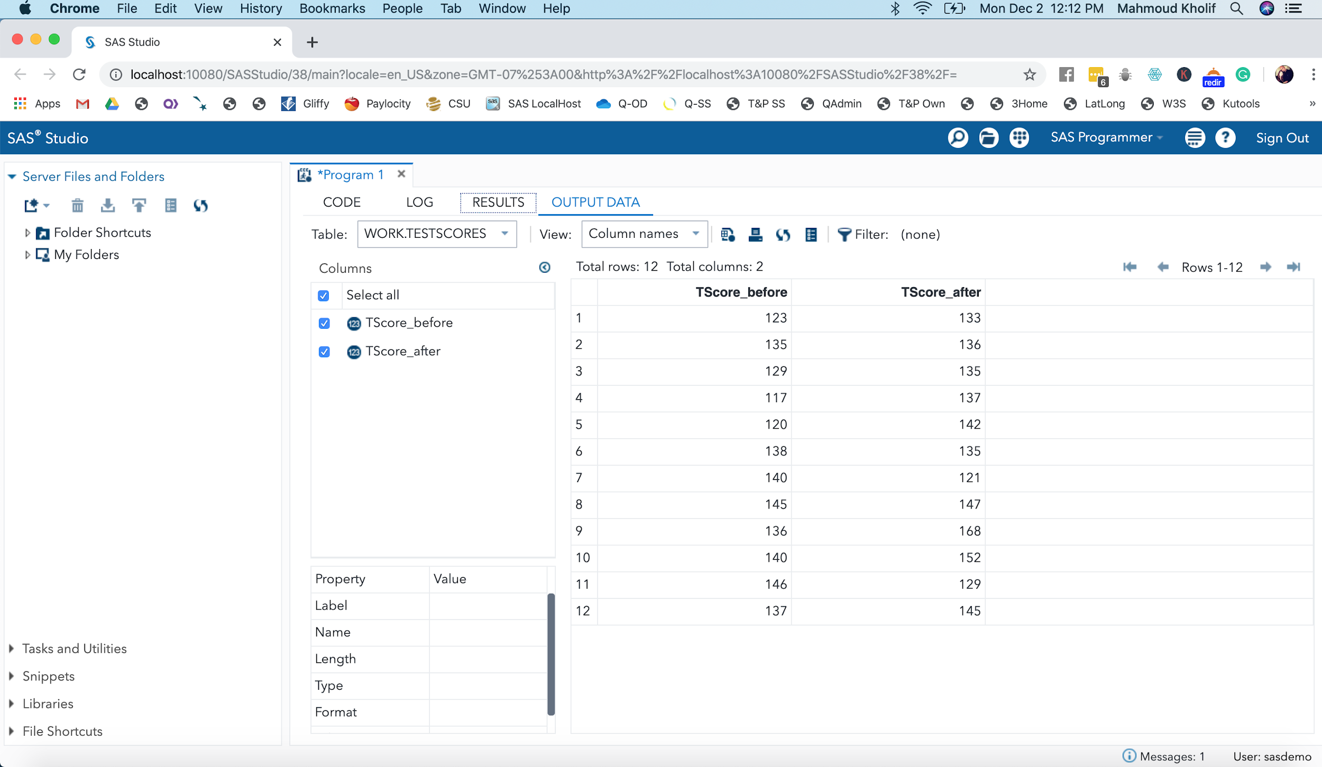

**proc print data=TestScores;**

**run;**

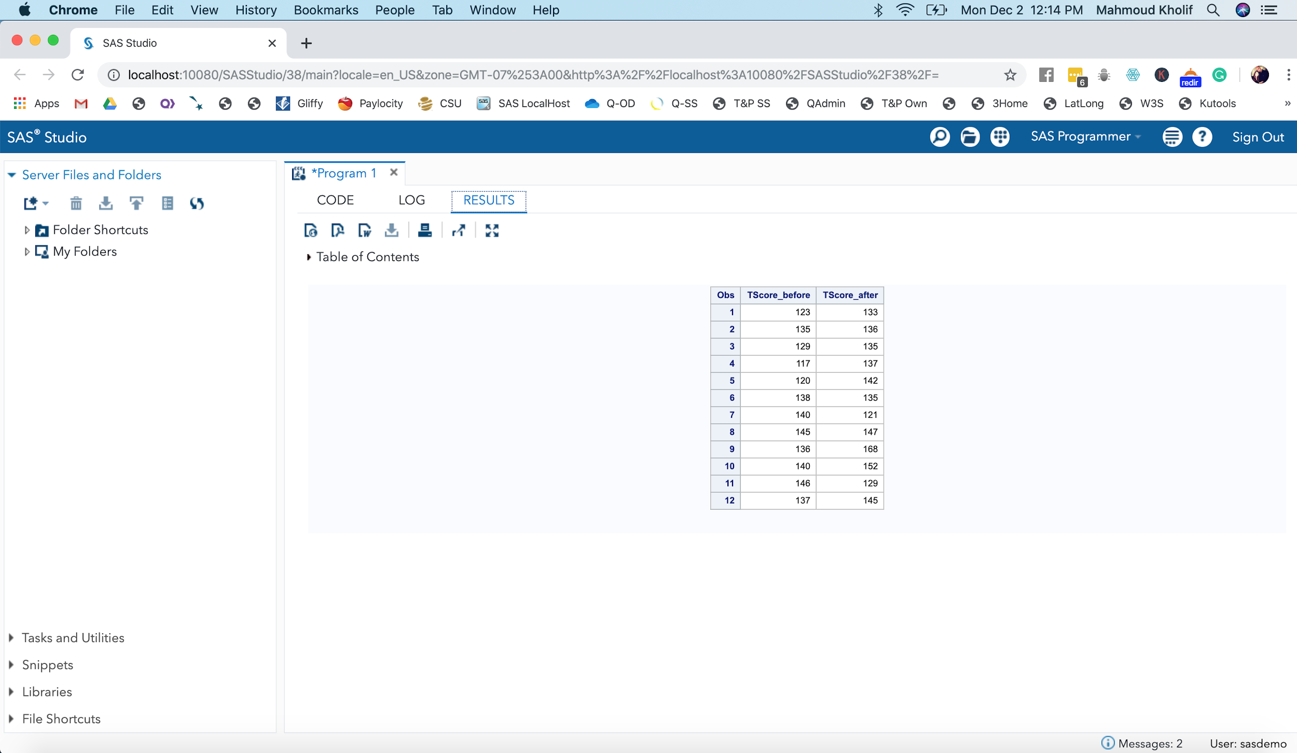

**ods graphics on;**

**proc ttest;**

**paired TScore_before*TScore_after;**

**run;**

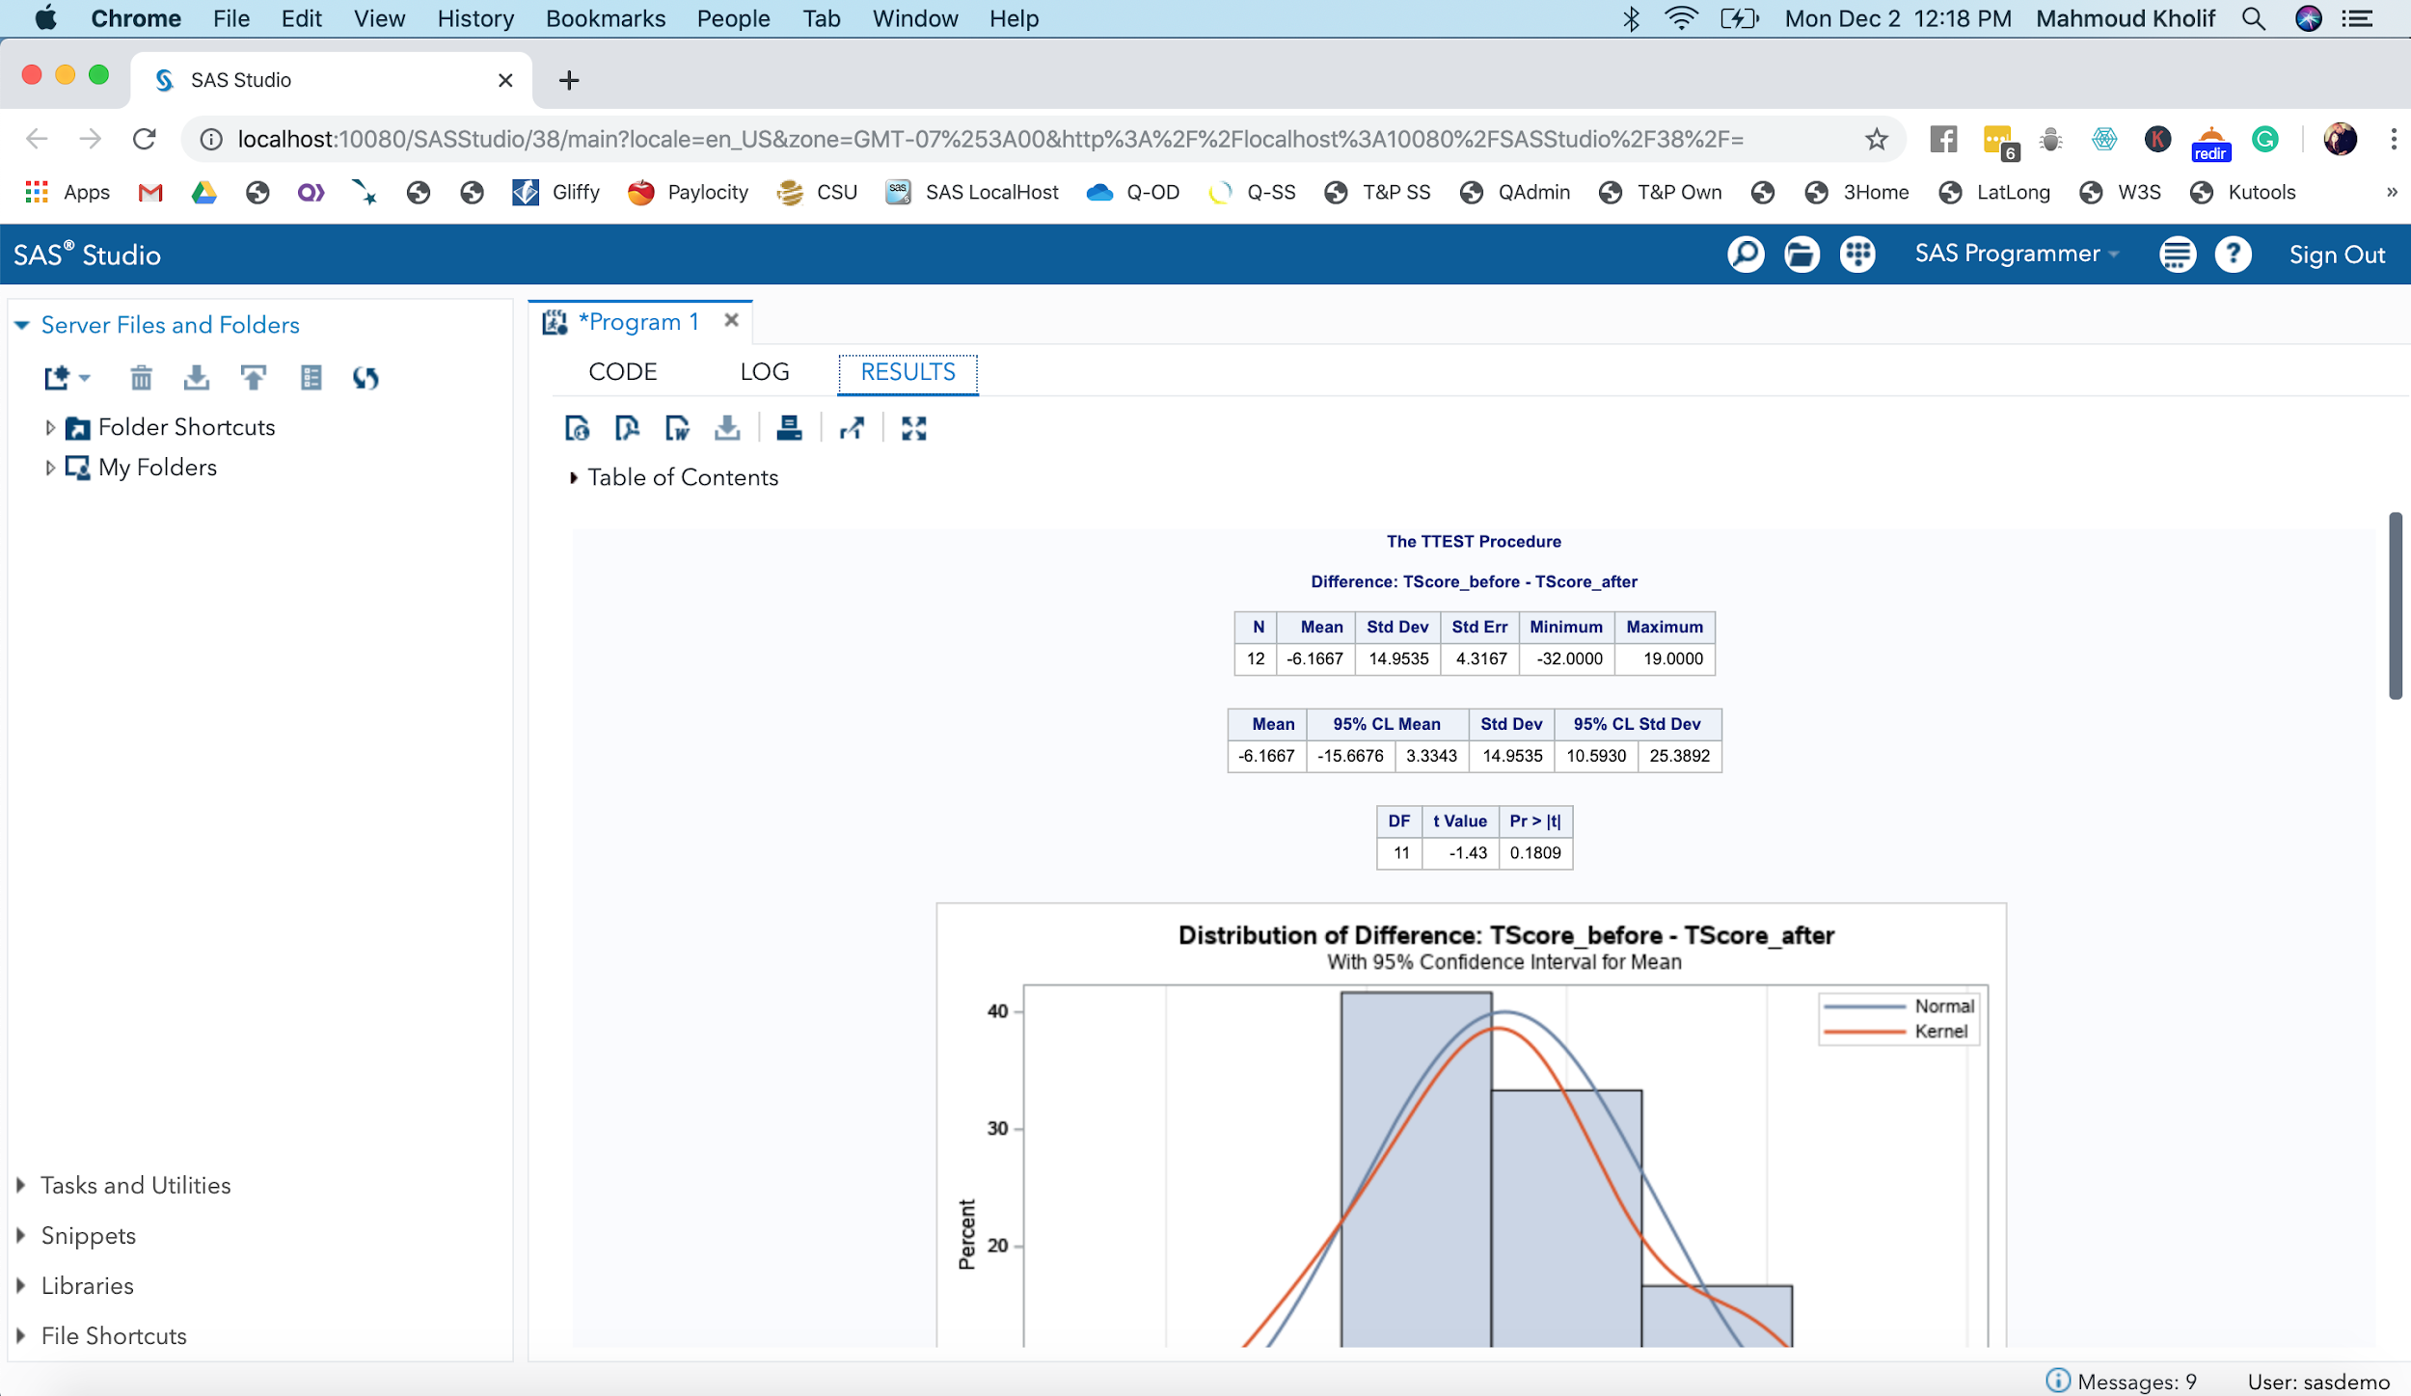

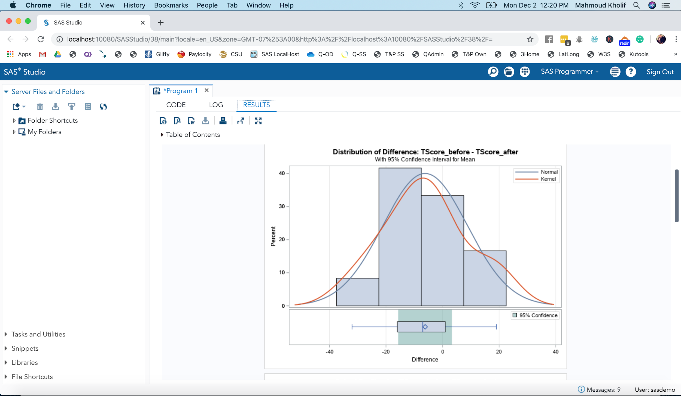

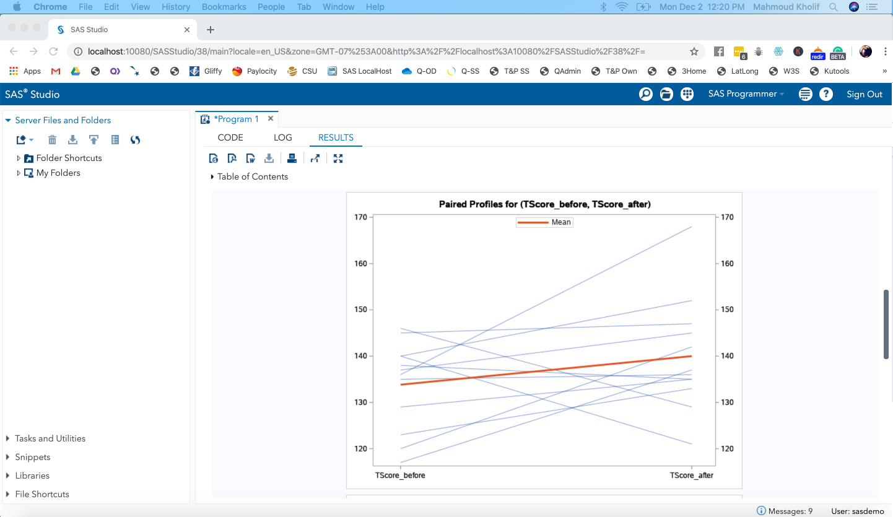

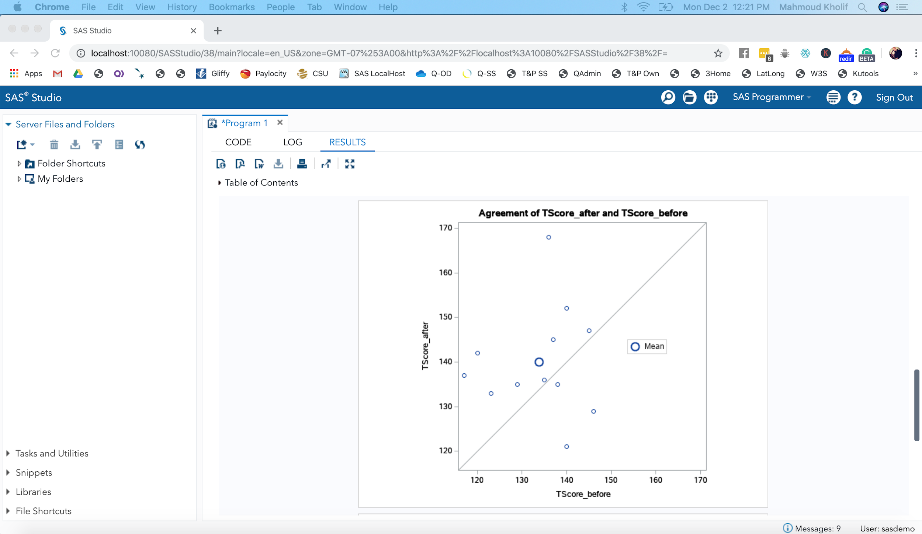

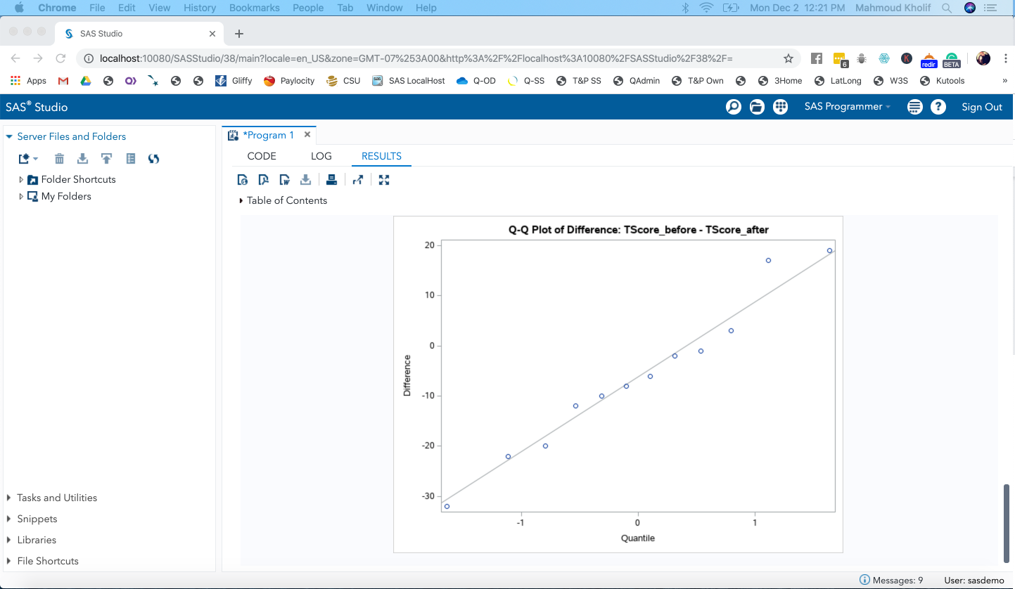

**ods graphics off;**

